**History of Kanban**

The first Kanban system was developed in the 1940's by a Japanese industrial engineer and businessman named Taiichi Ohno who worked for Toyota Motor Corporation.

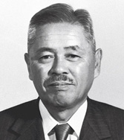 Taiichi Ohno

The Kanban System developed by these Japanese engineer was invented as a simple planning system which aim was to supervise work and inventory at every stage of production. It had the purpose to fight the inadequate productivity and efficiency in industrys and wanted to achieve higher throughput with lower delivery lead times.

The result that Ohno wanted was to control the entire value chain, starting in the supplier and ending on the costumer avoiding in this way supply disruption and overstocking of goods at various stages of the manufacturing process.

The first person to apply this concept to software development and knowledge work in general was David J. Anderson in 2004, while developing an project at Microsoft. By studying and perfecting the works of Edward Demmings, Eli Goldratt, Peter Drucker and others, Anderson had as result the Kanban Method, directionally related to pull systems, queuing theory and flow.

"The two pillars of the Toyota production system are just-in-time and automation with a human touch, or autonomation.” – David J. Anderson

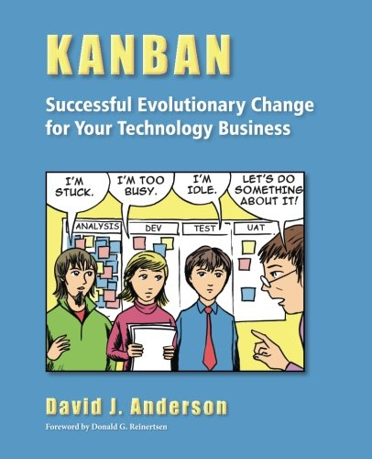

**The Kanban principles**

The Kanban Method in building software consists in gradually improving the development.

“Kanban is not a software development lifecycle methodology or an approach to project management. It requires that some process is already in place so that Kanban can be applied to incrementally change the underlying process.” – David J. Anderson

**The Kanban Board**

This method is based in a visualization, using as a tool a Kanban board.

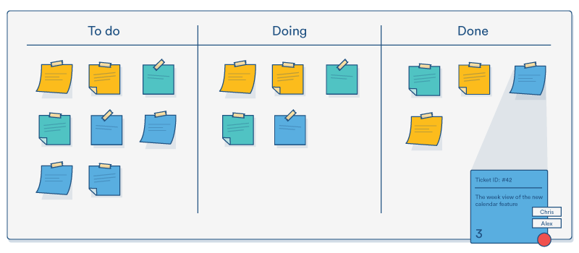

The observation of this board allows a better work and workflow management, providing advises limiting work in progress, permiting the reducion of the waste that results from multitasking and context switching and exposing the operational problems, stimulating the collaboration to improve the system.

As we can see in the board, it is divided in three categories:

* **To Do**: Tasks to work on
* **In Progress**: Tasks currently active
* **Complete**: Completed tasks

The path to execute these categories is starting in the **To Do** category, proceding to **In Progress** and ending at **Complete**. This is the basic path, because a more complex project would obviously require a more complex path with more categories, for example "**Planned**" or "**In Testing**".

The Kanban team that is working on the project meets the needs of the costumer and works on them. Usually this team is not large and has no strict roles, because these roles are defined by the needs in the project, but we can affirm that a typical agile team includes analysts, project managers and testers. Two important roles we can highlight are the Service Delivery Manager and the Service Request Manager.

**The Kanban Cards**

As we can see in the image of the board, each column has Kanban cards in it. They are simply written messages that indicate the need to replenish a specific component, representing a task.

Some fields of this cards at the simplest level are for example:

* ID: The unique identifier
* Assignees: Persons working on the task
* Description: What the task is.
* Type: The type of the task.
* Timeframe: Time expected that the task will take
* Blocked Indicator: Whether is or not a blocked card

This cards are a fundamental part of the agile Kanban process.

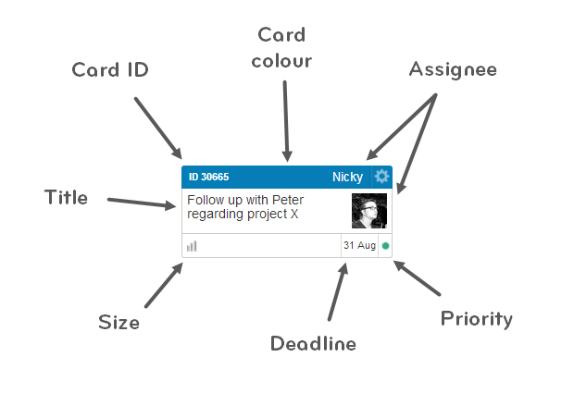

**Blocked Cards**

These type of cards are usually indicated with a red marker at the corner of the corner, meaning that the progress on the card is suspended until another action is taken.

**Practices**

Kanban has six general practices:

1. **Visualization of the work flow** - Creation of the board according to the complexity of the work
2. **Limiting Work on Progress** - Encourages the persons who are working to complete the task at hand before takin up another more recent work, creating in this way more capacity in the system, so new work can be pulled in by the team - 'Pull-system'
3. **Flow Management** - Control of the workflow and the work status at every stage
4. **Making Process Policies Explicit** - Process rules that explain what to do at each step
5. **Using feedback loops** - The Kanban method encourages and helps the implementation feedback loops or the lack of it
6. **Collaborative or experimental evolution** - By using this agile method, we are submitted to an evolutionary improvement process which helps to adopt small changes and gradually improve at a pace and size easy to handle

**Advantages and Disadvantages of the uses of Kanban Method**

As every software process, this method as Pros and Cons:

* **Advantages**

1. **Allows for Flexibility**

Despite the use of basic concepts is very flexible to implement the Kanban methodology by allowing the modification of the board, cards and respective content.

1. **Forces Event-Driven Workflow**

Everything is based on cards that represent tasks and their progress across the development stages on the board, turning this method entirely event-driven and allowing the team to constantly adapt as the cards turn prominent while other can be ignored

1. **Reduction of the waste**

Kanban encourages not only transparency but also an agile workflow permitting that the team stay abreast of the components progress in the project.

* **Disadvantages**

1. **Complexity Potential**

The possibility of the creation of a board over-engineered and complicated is increased according to the complexity of the project with the risk that the created system is too confusing to parse and use.

1. **Possible Bottlenecks**

Not planning for and dealing with blocked cards can cause hindrances waiting on one particular card or component to be done. Kanban reveals a particular danger because its focus on cards makes scheduling and milestoning more difficult.

1. **Required Constant Board Monitoring**

The Kanban board must be constantly monitorized to assure that the cards will not expire.

**Sources**

* https://www.digite.com/kanban/what-is-kanban/
* https://airbrake.io/blog/sdlc/kanban
* https://en.wikipedia.org/wiki/Kanban_(development)
* https://www.youtube.com/watch?v=R8dYLbJiTUE
* https://www.toyota-global.com/company/vision_philosophy/toyota_production_system/just-in-time.html
* https://leankanban.com/emerging-roles-in-kanban/